Revelio

**Rush Patterns & Utilization Report**

CAVE CAFE

horizontal line

# 

## Executive summary

* **Consistent rush week:** Week 4 of each month is the most active on average (≈ 312 orders), confirming a reliable end-of-month rush.
* **Peaks over time:** A modest negative correlation (–0.315) between month index and weekly orders suggests **later months are slightly weaker**, even though the week-4 pattern holds.
* **Holiday surges outside week-4:**  
  + April, week 1 shows a large positive deviation (+118) aligned with Eid al-Fitr.
  + June, week 2 spikes (+104) aligned with Eid al-Adha.
* **Rush hours and shifts**: Night shift dominates revenue (173.6k vs 52.6k Day).
* **Top hours**: 22:00 and 20:00 (by revenue and orders). However, **Day shift:** peaks at 15:00 and 17:00.
* **Strong calendar effects**: April and May are top months (by both revenue and orders). Friday/Saturday lead by weekday by orders , Friday/Thursday by revenue
* **Tables hot spots**: Tables **1, 8, 3, 6, 14** are consistently most used; these are likely bottlenecks during 21:00–22:00.

## Visualizations

Daily revenue with annotated Egyptian holidays. Notice surges in early April (Eid al-Fitr) and mid-June (Eid al-Adha).

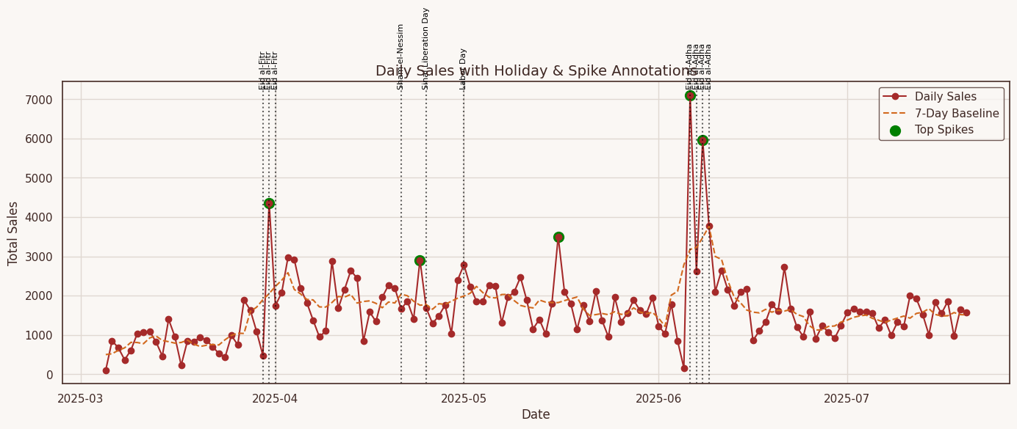

Rush hours concentrate at 20:00–22:00 (Night); Day peaks at 15:00–17:00.

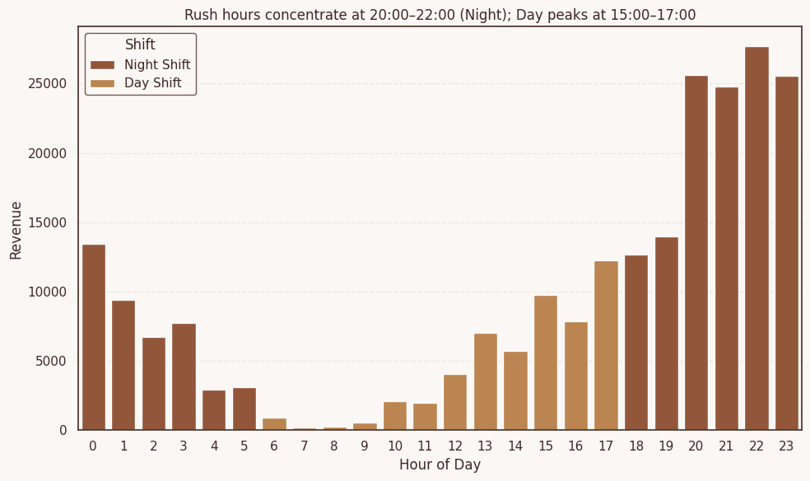

Weekend effect: Friday and Saturday dominate revenue.

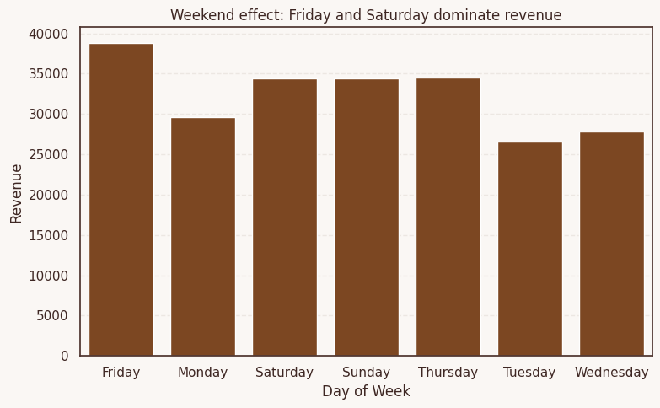

Seasonal decomposition

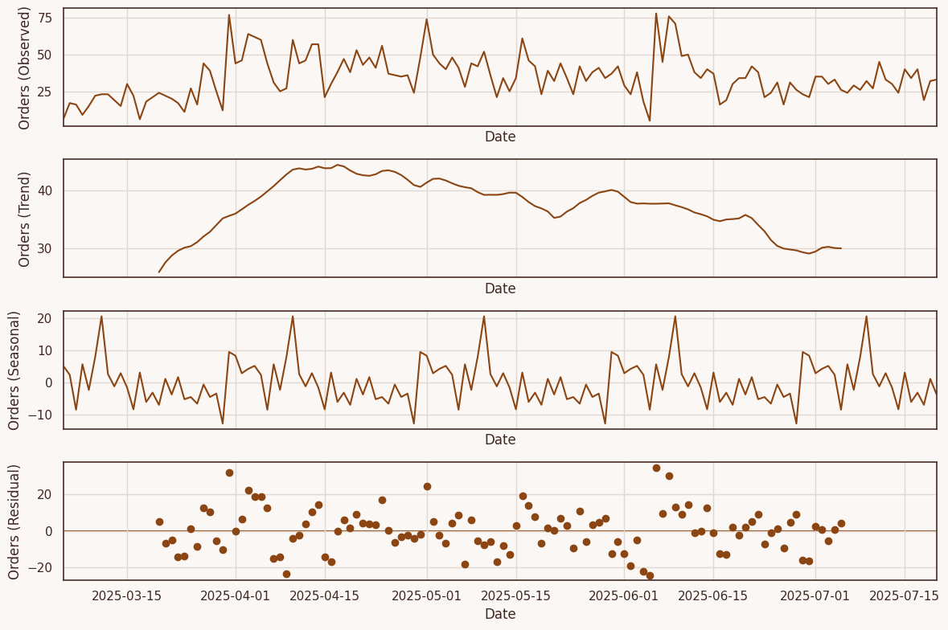

Peak-focus zooms (±3 days)

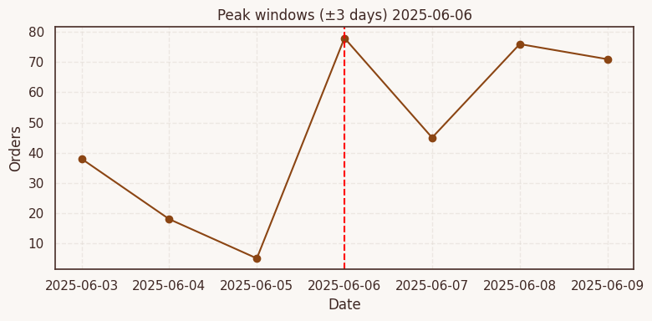

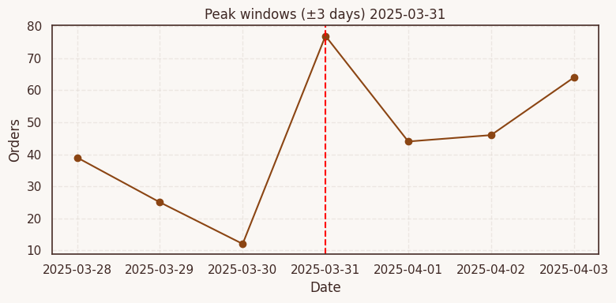

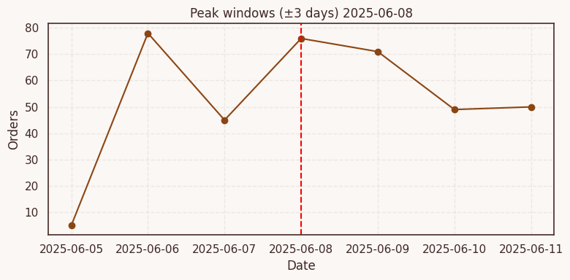

Where :

| **Date** | **Day of Week** | **Holiday Context** |
| --- | --- | --- |
| **March 31** | Monday | 2nd day of **Eid al-Fitr** |
| **June 6** | Friday | 1st day of **Eid al-Adha** |
| **June 8** | Sunday | Within **Eid al-Adha** period |

Top tables by utilization—focus on balancing load for tables 1, 8, 3, 6, 14

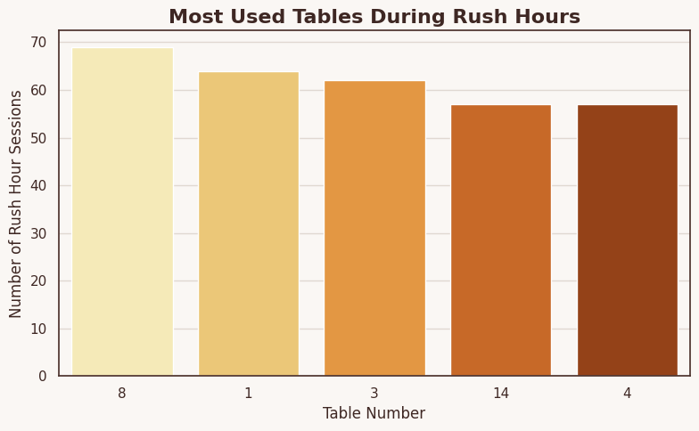

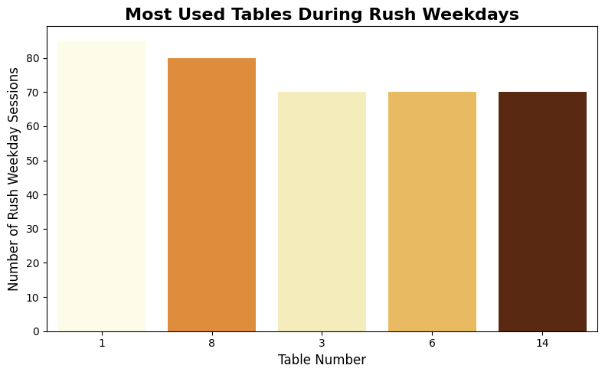

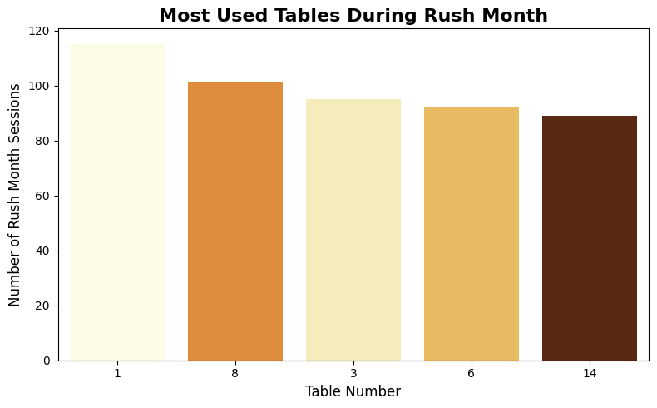

| Table Number | Table ID | Total Session Count |
| --- | --- | --- |
| 1 | b1_7OZYBC | 409 |
| 8 | b1_0V4WSM | 427 |
| 3 | b1_50357Z | 382 |
| 6 | b1_BJL0T4 | 301 |
| 14 | b1_LES6SG | 325 |